Field Day T-Shirts 2017 1st Grade Color: Safety Green (yellow tint)

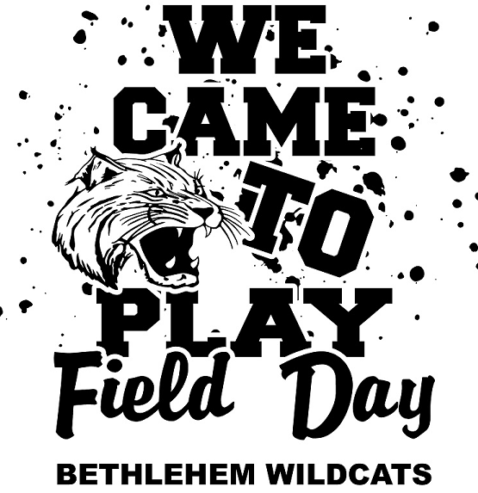

YS-AXL- $10.00 AXXL and AXXXL $12
Orders Due- March 22nd (no exceptions)
____________________________________________________
Name____________________________ Teacher______________________________
YXS (2-4) | YS  (6-8) | YM  (10-12) | YL  (14-16) | AS | AM | AL | AXL | A2XL  Add $2 | A3XL  Add$2
Total quantity_____________ extended price _____________

